STUDENT Joseph Roper

Salford City College | Future Skills

BTEC National 90 Credit Diploma in Creative Media Production

Unit 13: Understanding the Computer Games Industry

Contents

Financial 2

Contributors 2

Marketing Trends 3

Advertising 3

Industry/Gaming Trends 5

Virtual Reality (VR) 5

Task 4 6

Legal 6

Copyright & Trademark 6

Patent/ Registered Designs 7

Ethical 8

Violence 8

Rating 9

Education 11

Stereotyping 12

Addiction 13

Contractual 13

Employment 13

Development 13

License 13

NDA 14

Collaboration 14

Professional Bodies 15

UKIE (United Kingdom Interactive Entertainment) 15

IGDA 15

## Financial

### Contributors

Contributors are anyone who helps with a game without being involved with the company creating it such as by working for them or being paid by the company. Contributors can be: game testers, backers which are people who have given the game developers money before release to help them make the game, game testers, forums containing bug reports to give information to the developers to help them fix the bug which improves the game and finally a contributor can be someone on YouTube doing a let’s play of a game which then inclines the viewer to purchase the game.

An example of a game which without contributors would never exist is Undertale as the game was funded by the craters profit and mainly by the website Kickstarter where many people donated money to the developers, so the game could be made and released to the public. From this I have learnt that contributors can be helpful with games even though they are not usually paid even if it is something simple like someone making a video about the game which they like that could make people want to buy the game which of course helps the developers out. Also, I have learnt that as contributors such as you tubers can help with advertising for the game you should allow people to make videos of people playing your game without suing them for copyright like Nintendo used to do with their games which they received a lot of criticism for.

I believe games being funded by the public will be a trend that will stay in the industry. However, it will only work with small indie developers as if a big developer asked for the public’s money to fund their game people will be outraged. This has happened in the past when Atari wanted to bring Roller Coaster Tycoon to the Nintendo Switch. But it asked the public to pay for the games development on a crowdfunding campaign created on Start Engine, this stirred up the community resulting in them boycotting the game and ruining Atari’s reputation.

<https://www.youtube.com/watch?v=s1S4uXdfFMk>

[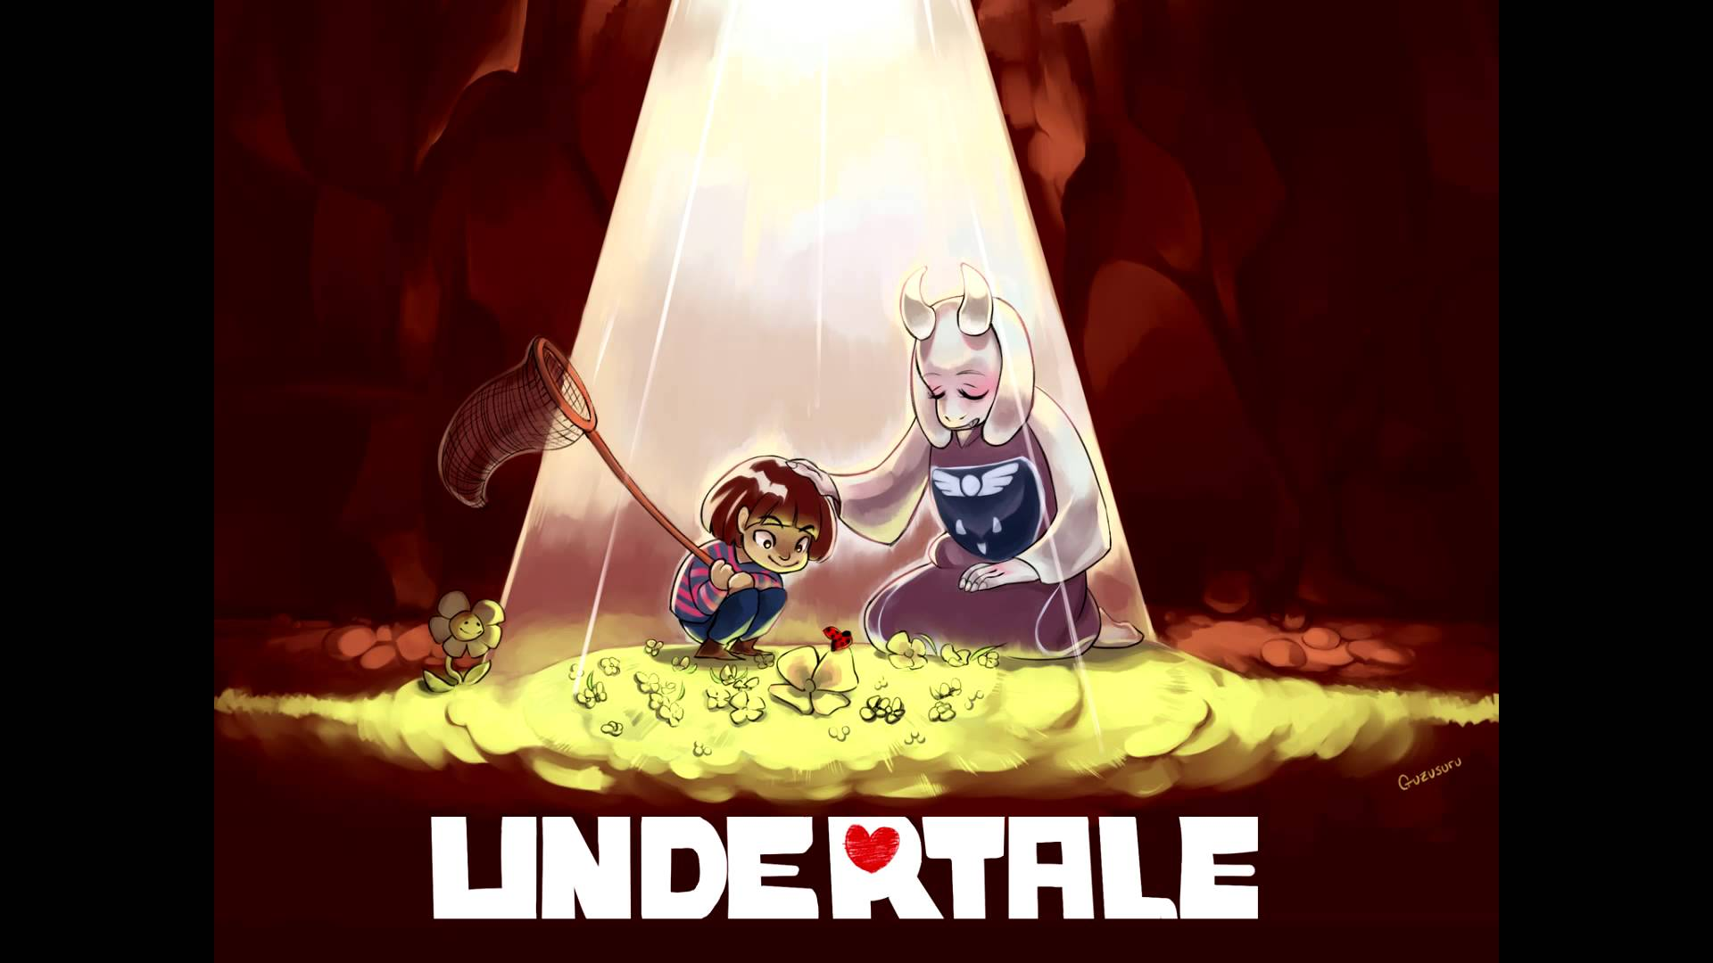](https://www.youtube.com/watch?v=bzeqvmQulO0)

[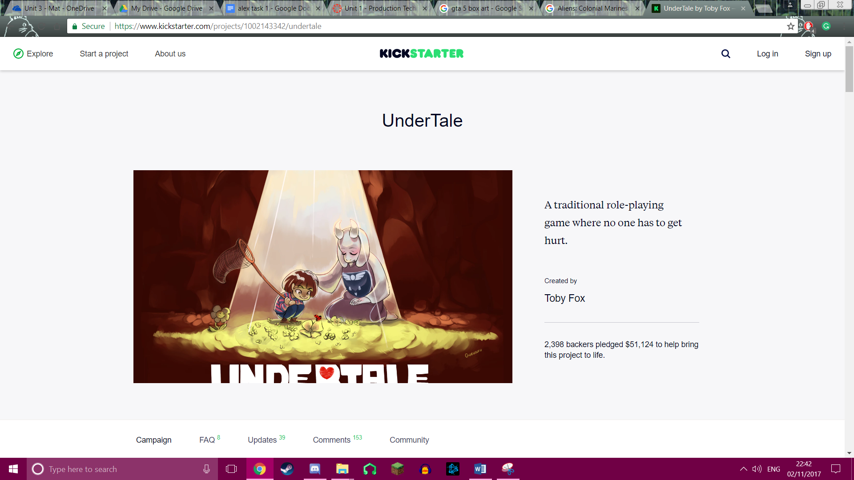](https://www.kickstarter.com/projects/1002143342/undertale)

## Marketing Trends

## Advertising

Lately adverts for games and other products in general have been slowly transitioning from television to online websites such as YouTube and other social media sites. This is because the target audience for games is usually of a younger audience which acquire their visual entertainment from the internet rather than TV meaning game developers would want to advertise their game on the internet so more of their target market see it. Another reason for adverts to leave the television is that it is a lot cheaper to advertise on the internet rather than TV. To run an advert on YouTube it usually costs around $0.10 to $0.30 per view that would mean if 10,000 people saw your $0.10 add you would only have to pay $1000 whereas to have an advert on TV the average cost would be $123,000 which is a lot dearer even though you will most likely get the same amount of views or even lower according to my sources.

YouTube Adverts: <https://www.bluecorona.com/blog/how-much-does-it-cost-to-advertise-youtube>

TV Adverts: <https://fitsmallbusiness.com/tv-advertising/>

I believe this trend is going to continue eventually leading TV to be a thing of the past meaning this is a current trend and most likely a future trend as well due to the youth of today not really interested into television and since most of the popular shows on TV are moving to YouTube for example all of the late-night talk shows such as Jimmy Kimmel.

[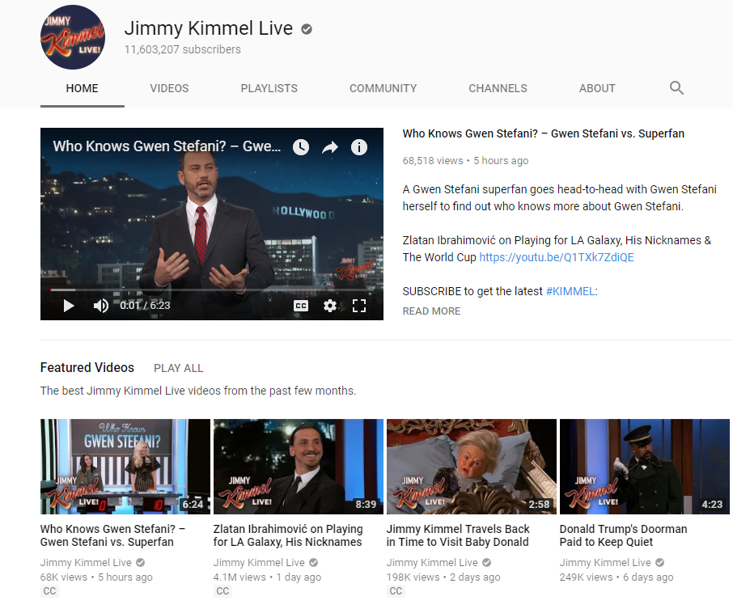](https://www.youtube.com/user/JimmyKimmelLive)

Another advertising trend that has spawned because of YouTube is game developers giving "Gaming YouTubers" their game to make videos on to advertise it to their fans, "Gaming YouTubers" are people who record themselves playing a game while giving a running commentary then they will post that video for people to see, some get up to 2 to 3 million views per video so you can see why a developer would want them to advertise their game for a short sum of money or sometimes even free. An example of this is with the “YouTube Gamer” InTheLittleWood or otherwise known as Martyn who got to play the demo of the game Ni No Kuni 2 early and he put his gameplay video on YouTube advertising the game as he got to play it early, the video was viewed 10,250 times by people from across the world. Meaning that Level – 5 developer of the game basically got free advertisement just for letting someone play the game demo early.

[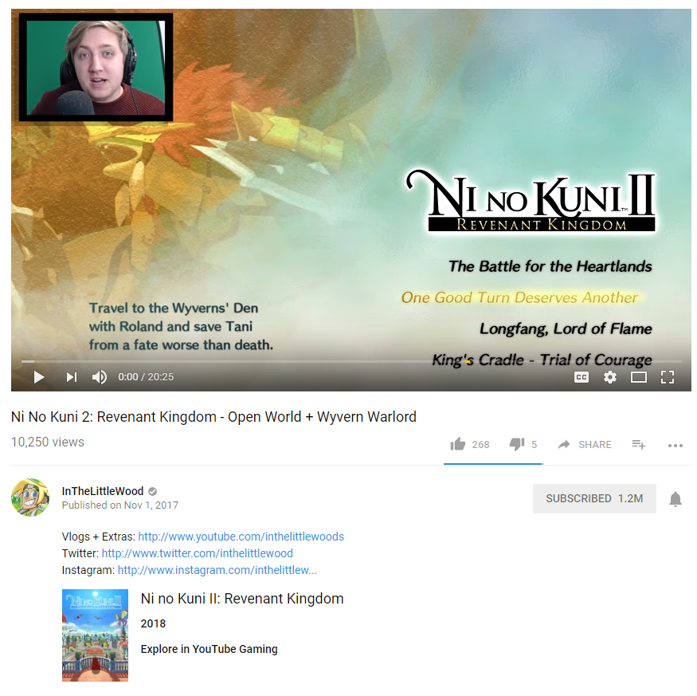](https://www.youtube.com/watch?v=2ggZUSj09Kk)

I believe this trend will stay as why it should leave although I do believe the YouTubers will start asking for more money meaning there will be less developers wanting to do this as it might cost them too much.

## Industry/Gaming Trends

### Virtual Reality (VR)

A gaming trend that has recently come into fruition is virtual reality (VR). Virtual reality is a computer generated simulation which is intractable. Virtual reality is mainly associated with the gaming industry with the Oculus Rift, HTC Vive, Samsung Gear VR and finally the PlayStation VR or PSVR for short.

Virtual reality often uses something called 3D VR sound to help immerse the player even more into the world. 3D VR sound is like surround sound except heavily improved as before with surround sound you had an idea of where a shot was fired but you had to guess where the enemy was based off that whereas with 3D VR sound you will be able to pin point where the shot was fired. This is achieved from sculpting a human head and putting microphones where the ears are so the microphones pick up sound exactly as we do in the real world.

[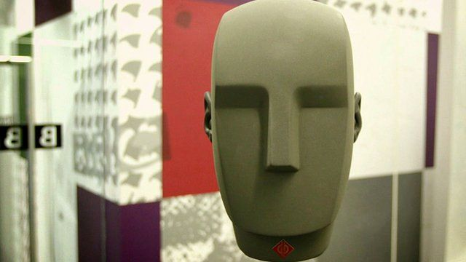](http://www.bbc.co.uk/news/av/technology-36138003/how-this-head-is-helping-give-you-3d-vr-sound)

I believe virtual reality is a current trend but is also one for the future as technology is forever developing and VR definetly needs it as in my opinion currently VR gaming is currently a novelty purchase as there are few games worth playing on the system such as Super Hot, however with further developments in VR it would become a worthwhile purchase. To make virtual reality worth it for me it would have to have more fun and large games, better graphics in the headset and well the technology present in the movie Ready Player One. In this movie there was a omnidirectional treadmil which is actually real and functional as present by this video however game developers haven't yet implemented it into any major games.

<https://www.youtube.com/watch?v=SVs7iegtDIk>

[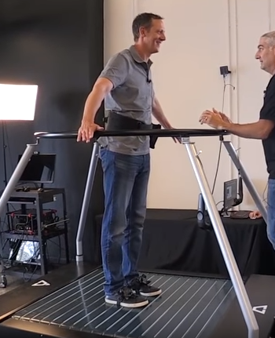](https://www.youtube.com/watch?v=SVs7iegtDIk)

# Task 4

## Legal

### Copyright & Trademark

If a piece of audio is copyrighted by the creator this means the piece of audio is protected under certain rights. This allows the creator to sue someone who uses their piece of audio without permission or if it is used unfairly. Fair use is when a piece of audio is used correctly under the copyright laws, for the use of a track to be fair it must have a good intention, not use too much of the song/track and finally to not represent the song/track in a bad manner. Also, you can purchase copyrighted music for example and have the ability to use it for a limited time before the contract expires. A copyright can last for the life of the creator plus 70 years, a creator can sign a copyright share to a publisher for a stream of income, 35 years after the share you can take the copyright back. Many years ago, creators used to put their song or lyrics in an envelope and send it to themselves and keep the receipt and never opened it until someone copied their music then they would sue the person who copied and show the receipt and envelope to the judge and then they would win the court case, this is still valid today. Creators did this as it used to be very expensive to copyright something and lawyers/solicitors were too. Also copyrighted things such as pictures usually have the copyright symbol on it, but the copyright symbol does not actually have to be there to be copyrighted.

[](https://www.thespruce.com/copyright-symbol-on-windows-and-mac-2688246)

When producing a game there are regulations and codes of practice that must be constantly taken into consideration by the publishers and developers. Trademarks and copyright need to be looked at as well as if a developer is using someone else’s sound library they will have to ask the creator of the sounds if it is ok to use the sound in the game or if he must buy a license first. This is also needing to keep a game developer’s assets safe such as game characters, logo’s and box art which is protected by copyright. An example of this is if you were to make a game and use one of Nintendo’s characters such as Mario or Link without their permission they could sue you and take the game down. This has happened previously with a fan made Pokémon game called Pokémon Uranium but because the game called the pocket monsters Pokémon and called the catching devices Poke balls the game was copying the Pokémon franchise and invaded the copyright law and even though the game was free it was still taken down by Nintendo.

[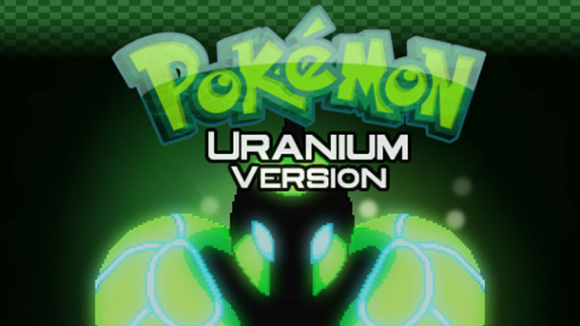](http://www.gameinformer.com/b/news/archive/2016/08/10/fans-come-together-to-create-the-original-unofficial-pok-233-mon-uranium.aspx)

### Patent/ Registered Designs

A patent is a legal certificate that gives you the right to protect your invention for up to 20 years. In the following countries; France, Germany, Australia, England and the United States of America (U.S.A.) patents can protect products, devices, systems, compositions, processes, methods and uses however patents cannot cover ideas for example Nintendo couldn't patent the idea for Arms (A boxing game for the Nintendo Switch) while it was in development, they could only trademark the name and characters. This is why in 1998 and onward you had animation companies making movies with the same idea for example A Bugs Life & Antz because they couldn't patent their original idea, this is known as twin films. If someone were to infringe another’s patent they can be charged for several penalties the most likely penalty will be to award damages to the patent owner meaning they will have to pay the owner a certain amount of money.

[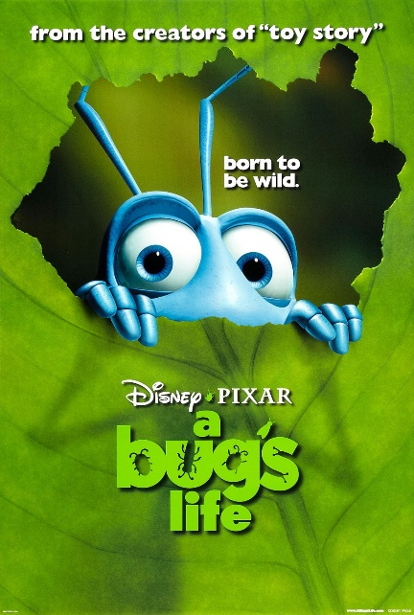](http://pixar.wikia.com/wiki/A_Bug's_Life_Trivia)[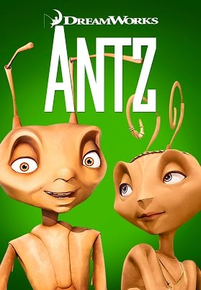](https://www.youtube.com/watch?v=iX_qRwVXWYQ)[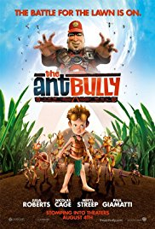](https://www.imdb.com/title/tt0429589/)

## Ethical

### Violence

Violence in games has always been an issue in the gaming industry less now than what it was in the 90's with the release of the first Mortal Combat in 1992 and Grand Theft Auto (GTA) in 1997, as this was a big shock to the public as beforehand games weren't that violent and didn't show blood especially the popular games such as the highly family friendly Mario games. Due to this, players parents were outraged and tried to make the game illegal to play as they though it would cause their children to become more violent which is obviously a lie, however this story made it all over the news and caused the video game rating system to be revitalised to what it is now with PEGI as if a game now contains violence or drugs it will most likely be rated 18 and will have to say that the game includes violence and drugs.

[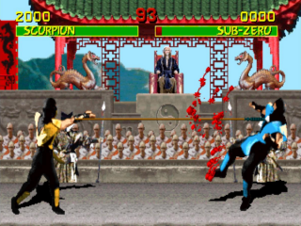](https://www.giantbomb.com/mortal-kombat/3030-15743/)[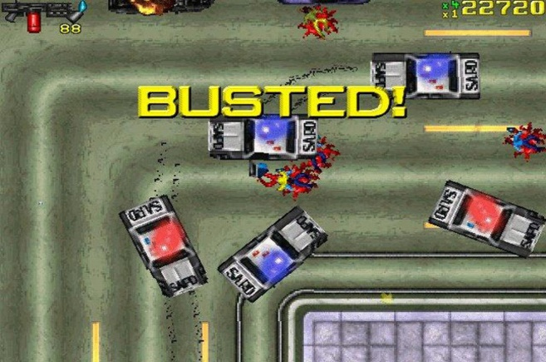](https://www.theregister.co.uk/2015/01/14/antique_code_show_grand_theft_auto_1997/)

### Rating

Another regulation is including the PEGI rating system on the box art of your game. PEGI stands for Pan European Game Information and is a video game content rating system and are labels which appear on the front and back of a games packaging which informs the purchaser what ages the game is suitable for which can protect underage children from violence and gore. The PEGI system has five different rating systems: 3, 7, 12, 16 and 18. An example of the PEGI rating system used is with the game GTA V (5) from this you can see that the age rating 18 can clearly be seen on the front of the games box art and on the back, it shows that the game contains bad language, drugs, violence and online multiplayer. From this I now know that if I make a game I will have to clearly show the game PEGI rating on the box art or I could get into trouble.

[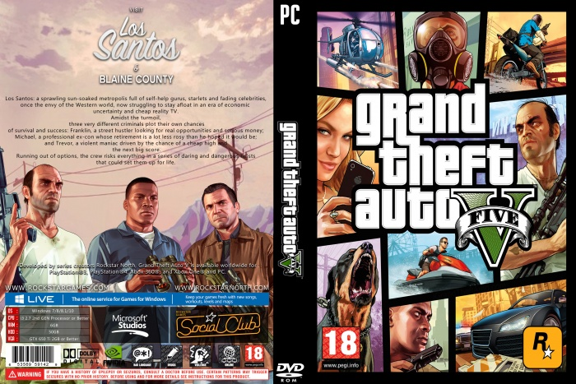](http://vgboxart.com/view/72052/grand-theft-auto-5-cover/)

PEGI 3:

This is rating is for games which contain comical violence such as Mario jumping on a Goomba. Also, the games should not contain any photo realistic characters getting hurt they have to be fantasy characters. The game should not scare the children playing and not contain any profanities.

http://www.pegi.info/en/index/id/33/media/img/320.gif

PEGI 7:

This is basically the PEGI 3 rating but with a bit more realistic violence and could contain some possibly scary scenes.

http://www.pegi.info/en/index/id/33/media/img/321.gif

PEGI 12:

This rating can contain little violence to photo realistic/human looking characters, minor swearing and a little bit of nudity such as a high skirt.

http://www.pegi.info/en/index/id/33/media/img/322.gif

PEGI 16:

This rating means the violence and or sexual activity has been raised to the point of realism and drug use can be shown in the game also criminal activities can be displayed and extreme bad language is prevalent. Games with this rating include Destiny 2, Uncharted 4 and W2K18.

http://www.pegi.info/en/index/id/33/media/img/323.gif

PEGI 18:

This rating is having the same qualities as PEGI 16 except with more revolting violence. A perfect example of this is with the game franchise Mortal Combat.

http://www.pegi.info/en/index/id/33/media/img/324.gif

On the back of the packaging of a game also contains pictures dictating why a game is that specific PEGI rating. There are eight such pictures: violence, bad language, fear, drugs, sexual, discrimination, gambling and online gameplay with other people.

http://www.pegi.info/en/index/id/33/media/img/269.gif

Bad Language:   
Game contains profanities.

http://www.pegi.info/en/index/id/33/media/img/270.gif

Discrimination:   
Game contains depictions of, or material which may encourage, discrimination

http://www.pegi.info/en/index/id/33/media/img/271.gif

Drugs:   
Game shows drug use.

http://www.pegi.info/en/index/id/33/media/img/272.gif

Fear:   
Game may be frightening or scary for young children

http://www.pegi.info/en/index/id/33/media/img/273.gif

Gambling:   
Games that encourage or teach gambling

http://www.pegi.info/en/index/id/33/media/img/275.gif

Sex:   
Game depicts nudity and/or sexual behaviour or sexual references

http://www.pegi.info/en/index/id/33/media/img/276.gif

Violence:   
Game contains depictions of violence

http://www.pegi.info/en/index/id/33/media/img/274.gif

Online gameplay:   
Game can be played online

### Education

Games nowadays can be very educational and some are being used in schools to help with teaching. For example the game Minecraft is used to help students … Personally a game that I found educational was Persona 5, part of Persona 5's gameplay involves going to school in Japan during the school week you will often be asked questions ranging from history, different countries cultures, maths and the English language. From this I learnt various facts and a lot about Japan for example students in Japan go to school on Saturdays and that most schools in Japan have banned students from having part time jobs.

[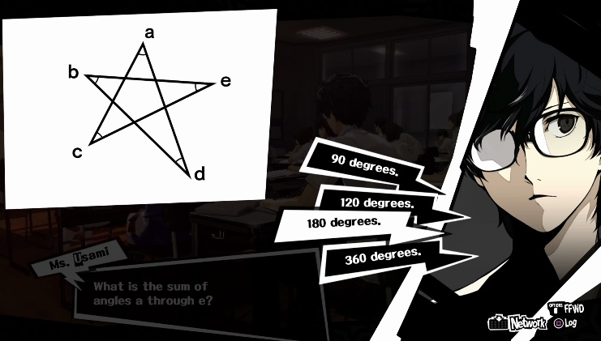](https://www.rpgsite.net/feature/5468-persona-5-test-answers-every-answer-for-school-class-quiz-questions-and-exams)

### Stereotyping

The reason for this being an ethical consideration is because usually when a female is in a video game they are sexualised. This is not really a problem nowadays but still woman in video games are still sexualised for example nearly every female character in the game Over watch is wearing a skin tight costume such as with the characters Tracer and Widow. With the picture below of the character Tracer there was a lot of controversy as when the game was first released one of Tracers’ emotes was too sexualised this is the one which faces her back, this was then changed to the other emote because people complained that it was too sexual. From this I have learnt that I should treat Females and makes the same in games and not overly sexualise characters in the game I make.

[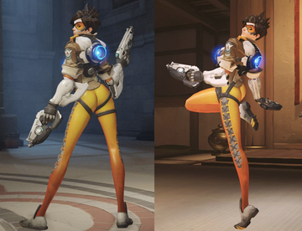](https://en.wikipedia.org/wiki/Tracer_(Overwatch))[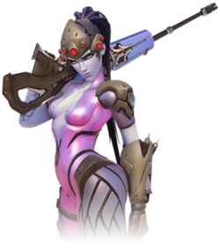](https://en.wikipedia.org/wiki/Widowmaker_(Overwatch))

Race isn’t usually a problem in video games as not many developers touch on it as it is a very controversial issue although when developers do such as in GTA 5 and South Park: The Fractured but Whole the race being affected don’t really care as they believe it is true. As in GTA 5 depending where you are in the game the police will react differently depending on what race your character is. Also in the game South Park: The Fractured But Whole at the start of the game in the character selection when you choose the difficulty of the game to make the game harder you have to darken your skin tone although there was not much of an outrage for this as it was just a joke and didn’t actually effect the game and people though it was true.

[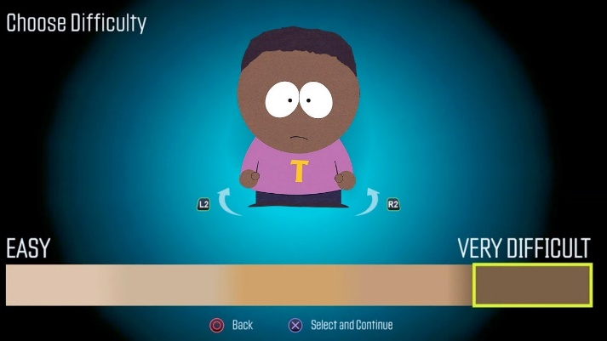](https://www.youtube.com/watch?v=oG6xFDLhO_c)

Religion is not really touched on a lot in video games as it is always a controversial issue and if a developer were to include religion in their video game even if they represented the religion fairly there would always be people who would feel offended so there is really no benefit with including religion in a video game.

### Addiction

Addiction is a serious problem in the gaming industry as games nowadays are designed to specifically be addictive so the players spend more time on the game and might even buy real world accessories and micro transactions for the game, because of this games have a bad view in the public image. An example of an addictive game is Persona 5 as myself and friends have personally become addicted to this game to the point where we will play the game for 4 days straight by not going outside and skipping meals. The video link down below tells a story about someone who got addicted to this game for a week, during this week he didn’t go outside, sleep, eat or wash he even forgot to pay the water bill for his house and feed his dog. Although this game may be addictive I rate it 10 out of 10, a must play.

<https://www.youtube.com/watch?v=eqr9ttdzwGU>

[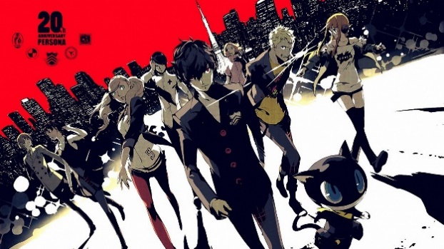](https://www.polygon.com/2017/12/8/16752562/persona-5-best-games-2017)[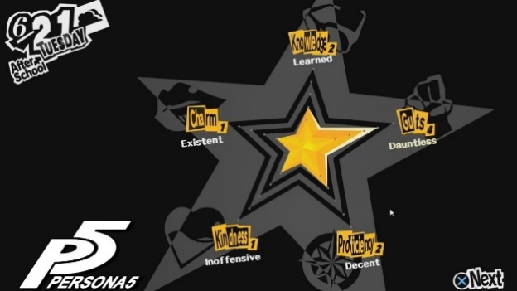](https://www.youtube.com/watch?v=87q2JB153TE)

## Contractual

### Employment

An employment contract is an agreement between employer and employee written down. An employment contract will include the wage the employee will receive, along with the amount of holiday days as well as payed holidays, hours and various other things that the employer and employee will discuss to reach an understanding with their business relationship.

### Development

Publishers often hire other game developers to help with their workload for this the two companies will need to form a development contract. The development contract will include the form of payment for the agreement, the workload between companies for the games development and varies other things will be discussed and included into the contract between the two companies regarding the games development.

### License

When licensing an audio product such as a song you have to say what it will be used for and where it will be used, this is the term and the territory, then if the creator of the song agrees you then buy that license and then you are free to use the song for that specific purpose. For example, if a game developer wants a specific song for a cut scene they will get a license, so they are able to play the song only on that cut scene. However, if the game developer then uses the song in another game or cut scene they could be sued by the creator of the song as they didn’t have the specific license to play it on that game or different cut scene.

Another example is with the game Mario + Rabbids Kingdom Battle, this is a game developed by the games company Ubisoft which features Nintendo's beloved character Mario and many others from that franchise. To be able to include this character in their game they would have had to make up a contract containing what they can and can't do with these characters for example in the game you have to have Mario in your party at all times so you can't play without one of Nintendo's own IP in the game. Also the game is only allowed to be on their new console the Nintendo Switch, I'm sure there were many over points that Ubisoft couldn't ignore such as not having blood in the game as Nintendo is a family friendly company and I'm certain that there would have been a rule stating that Nintendo had to look at all promotional material and the game and give the ok before it was released.

[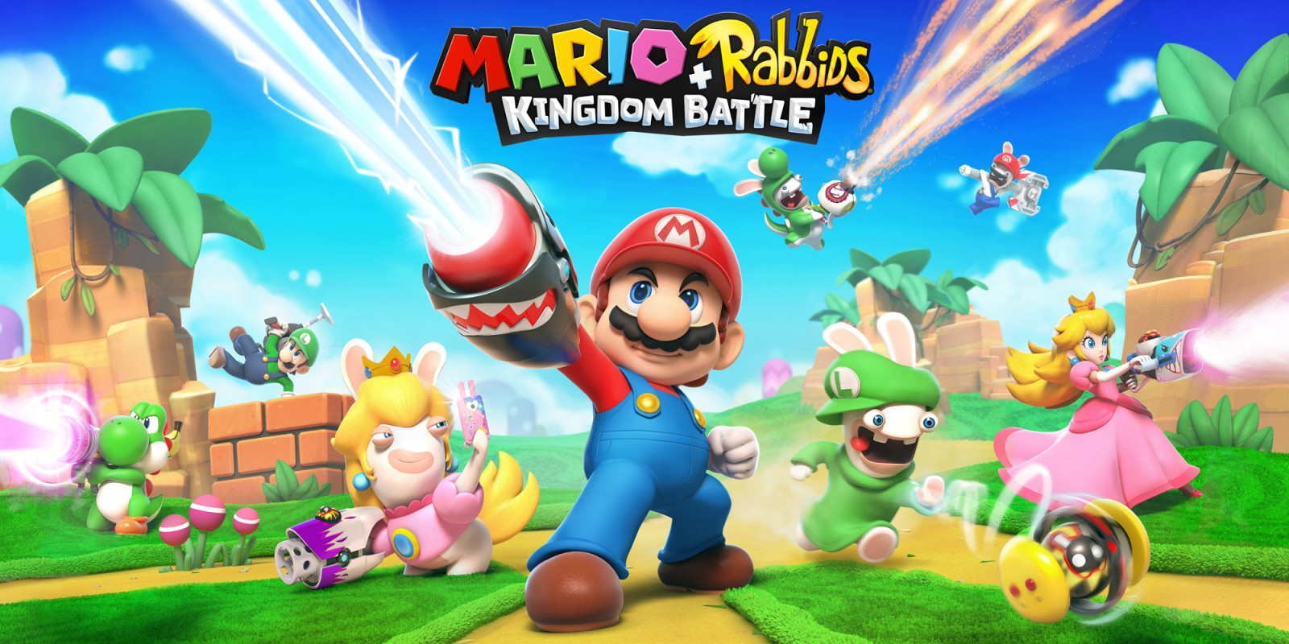](https://www.nintendo.co.uk/Games/Nintendo-Switch/Mario-Rabbids-Kingdom-Battle-1233954.html)

### NDA

An NDA or otherwise known as a non-disclosure agreement is used to keep confidential information secret from the public between business partners. When two companies work together on developing a game an NDA will most likely be used so that both companies information is not leaked to the public for example for the game Mario + Rabbids Kingdom Battle Nintendo and Ubisoft would have signed an NDA so that none of their employees would divulge information about the game to the public such as characters, gameplay and story events. If you were to break an NDA contract by releasing private information you could be faced with huge consequences in a court of law usually ending in you receiving a fine, loss of your job and future job prospects and many more inherently bad outcomes that will influence your future career.

<https://www.quora.com/What-happens-if-someone-breaks-a-non-disclosure-agreement-NDA>

### Collaboration

A collaboration is like a partnership in business, it is used with small businesses but in this case indie developers who want to work together. When collaborating you will want to create a document stating what roles will be separated between the partners, who owns the IP and mainly how you will share the profit.

## Professional Bodies

### UKIE (United Kingdom Interactive Entertainment)

UKIE is a non-profit trade body that helps British game developers publish and market their games. UKIE will represent both small start-ups and even large multinational developers as well as, publishers, service companies, working across online, mobile apps, consoles, PC, eSports, VR and AR basically everything to do with the gaming industry UKIE will represent.

What UKIE does is they will give advice and business support to the people they represent so if they are sued UKIE will help them out and protect them by all means so that they don’t go bankrupt. A good quote from one of UKIE’s members is “UKIE is a force to be reckoned with for the UK games industry. Passionate, informed, smart, focussed, driven and totally committed to the future success of the whole industry. Proud to be a member.” This is from UKIE’s 28th Annual Review and it perfectly sums up why they are such a good organisation as they will do anything to protect the gaming industry.

<https://issuu.com/uk_ie/docs/ukie_review_2017_final_online/2?ff=true&e=10369775/53375207>

One way UKIE helps out the gaming industry is through one of their many campaigns called Next Gen Skills, this campaign successfully helped achieve putting computer science back into the national curriculum in the UK, so pupils can learn how to code in schools increasing their options for future careers. I believe UKIE is doing good work as without them I could have never been able to take computer science as a subject in secondary school.

[](http://ukie.org.uk/content/our-campaigns)

<http://ukie.org.uk/content/our-campaigns>

### IGDA

The International Game Developers Association (IGDA) is the largest non-profit membership organization in the world serving all individual game developers. The IGDA is similar to UKIE in that they are helping companies large and small no matter if they are indie or AAA studios to help them make better games and to protect them with a big national body. The main difference between the two companies is that the IGDA is an international organisation whereas UKIE is only based in the UK meaning that the IGDA has more reach over the public eye and can raise more awareness for game developers.

The IGDA mainly use their resources to hold a bunch of conferences known as webinars which game developers can watch on their YouTube channel to be informed about various techniques they can use in game engines such as unity. For example from the picture down below you can see that this webinar will inform developers on how to get great sound and music for their own games. I believe the IGDA’s content is really useful for game developers and I think they should keep making webinars.

[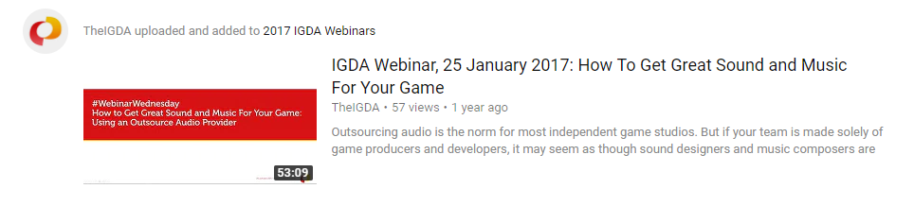](https://www.youtube.com/user/TheIGDA)